**Assignment : 1**

1. Check Positive Number:

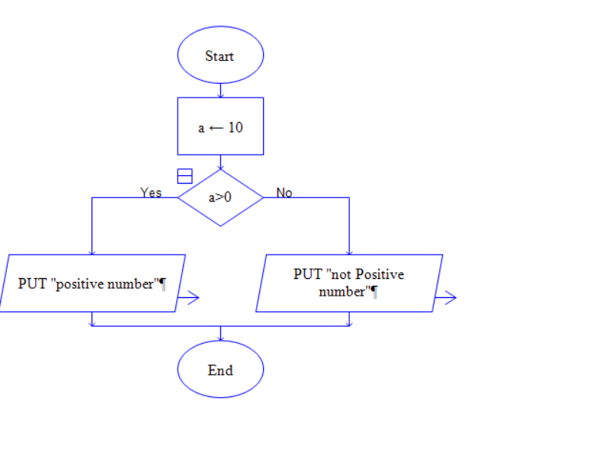

1. Check Negative Number:

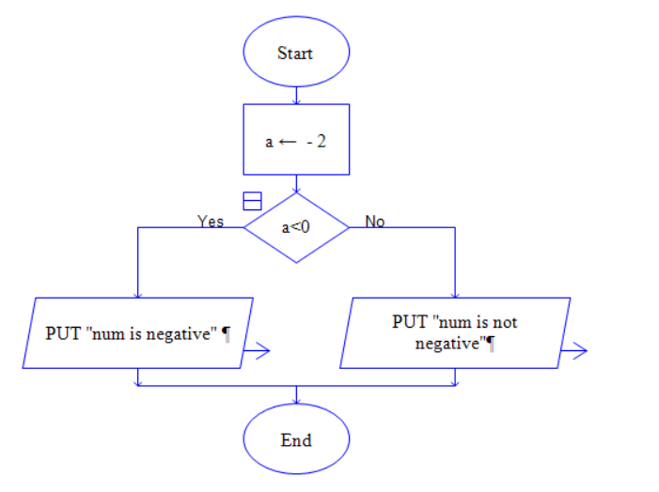

1. Check Odd or Even Number:

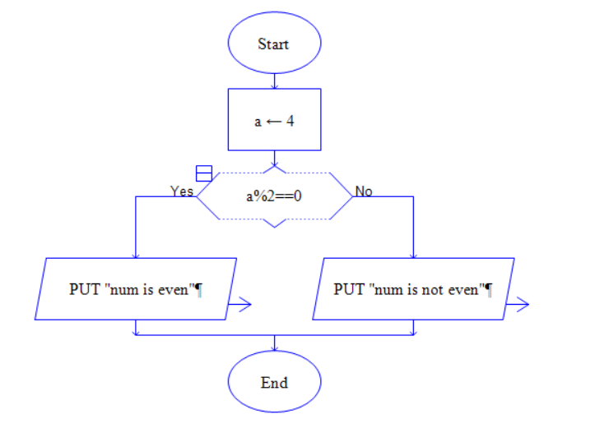

4. Display Good Morning Message Based on Time:

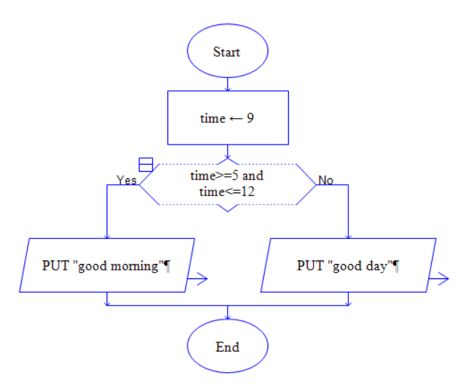

1. Print Area of a Square:

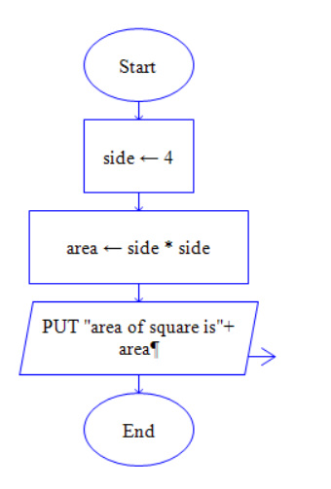

1. Print Area of a Rectangle:

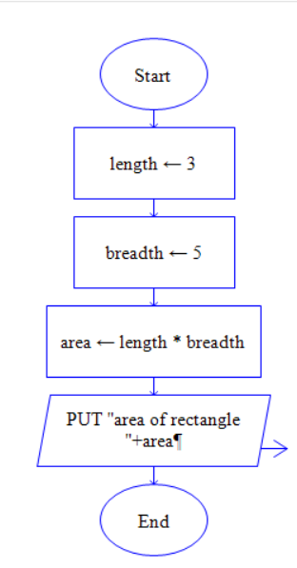

7. Find the Largest of Three Numbers:

